# Evaluation of possible technologies

**Introduction**

The initial scope of this project and discussions with Numatic about the type of system they wanted, allowed the client to develop basic requirements and to decide on the technologies that will be used in development.

There are of course many different types of system that could be developed; from desktop applications, web applications and phone/table applications. Currently SupportWorks; a desktop application, is used on site at Numatic. They have stated that they would be open to any type of system providing there is a strong justification and benefit provided to the company upon choosing that method. They are also looking to reduce the cost as much as possible, currently Numatic is having to pay for licencing the current system but also maintenance fees of the SupportWorks application.

**Web vs desktop application**

Both type of application would require the use of a server within the company; due to the database storing the data needed to be accessed by many people. If a web app was used, this would be accessible to employee, by the use of localhost; reducing the storage of an application on an individual machine. However this may become problematic if there was an incident involving the server(s) being down, although it is noted that the current is also reliant upon the server and would also not work in this situation.

After discussions with the client they would like to move to a web application in line with other systems used at Numatic including the Product Lifecycle Management Portal (PLM Portal) and the complex intranet that serves the company. This also reduces the network team’s job of having to install an application onto the user’s computers and allows the application to be used from any computer as nothing needs to be installed.

**Possible Technologies**

The front end will be developed with HTML and CSS, to create a simple and easy to use interface. There are different options of technologies to develop web applications, the most common being client side language of PHP with a MySQL database or ASP.NET and MSSQL. These have been further investigated below:

When choosing a client side scripting language many aspects were taken into account – as seen below, this was then present to the client for discussion allowing an informed decision to be made by Numatic.

|  |  |  |
| --- | --- | --- |
|  | PHP | ASP.NET |
| Cost | Completely free | Cost associated with a development environment – Visual Studio |
| Performance | PHP is often regarded as high performance, especially when utilising the use of LAMP – Linux, Apache, MySQL and PHP; which has been optimised for performance. | ASP.NET also performs well with MSSQL |
| Support | PHP is free and very popular, there is a large support network and forums dedicated to PHP | Not as widely used or has such a large support community. |
| Popularity of language | PHP is ranked number 6 of the most popular languages- as seen in fig.1 | Not included on the list – up to top 20 most popular |
| Ease of learning | PHP is easy to pick up, there are also many tutorials and tools to learn PHP online | ASP.NET is considered more complex and harder to learn than PHP. |

From these comparisons it is clear to see that PHP holds many benefits to the client mainly the fact it is completely free, it can perform to all of Numatic’s requirements and has a wide range of support online. After discussions with the client and the developers at Numatic the PLM portal has also been developed in PHP, therefore it makes sense for the client to be consistent with development technologies. This means that once the system has been transferred to the client there will be suitable support to maintain the system and possibly develop the system over time as the developers at Numatic are familiar with PHP.

Fig. 1 – TIOBE Index of popularity

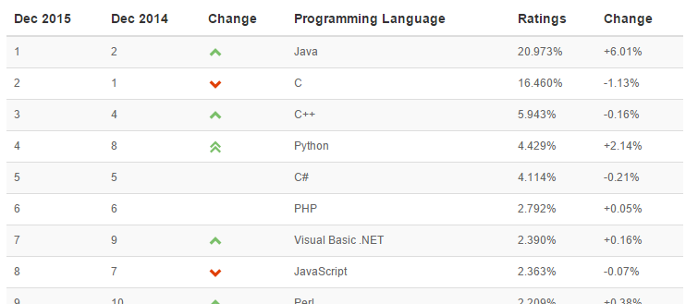

**Security**

The system will be hosted on Numatic’s internal server and while security will still need to be thought about in detail, it will not have to meet the standard required to be hosted online. Methods such as authentication and basic encryption will be deployed, to stop unauthorised people from accessing information.

One benefit of going with a web application is the ability of putting it online, to allow employees who are off-site to access the helpdesk. This scenario is currently out of scope for this project; although this could be a possible development in the future. If this development was carried out, then extra security measures would need to be added and carrying out penetration testing would allow any vulnerabilities to be exposed.